Name:
Course:
Assignment Title: Personal Narration
Date: 19th October 2021;

There is nothing that is wrong or right in life except for a few rare incidences. Wrong or right is relative. People often regard doing what they love or success as the pinnacle. However, what they fail to recognize is that they are an approach to a journey rather than a destination. One does what they love when they decide to view every moment as an opportunity. One is also successful when they decide to walk their path, learning while growing. It is one everyone to find what that opportunity or path is for them. My life has been a combination of good and bad experiences; experiences which have shaped part of whom I am today and what could have been viewed as a crippling setback drove me into a new path that led me to find a new interest and dream.
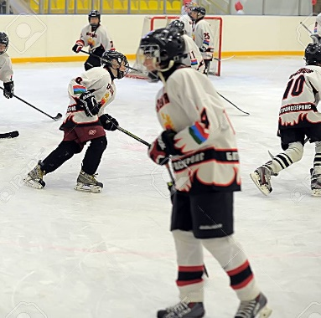
As a teenager, I fractured my hip bone and spine when I was playing ice hockey. This was one of the darkest and most agonizing period in my life. I was beginning to discover myself as a teenager, found my interest in playing ice hockey. I was resolute on becoming a professional ice hockey player playing in the National Hockey League. I used to support my hometown hockey team and watch both the United States men's and women's national teams with gloves on. I remember I acted out scenes and plays I had watched the hockey team execute with my hockey stick in our living room in front of the TV. My parents were chasing me out not to break things in the house. When I reminisce on those moments, I get goose bumps on what might have been. This was probably one of the best moments of my teenage hood.
When I fractured my hip bone and spine, I was almost certain my career in hockey was over before it even began. It dawned on me that my dream was falling apart. I underwent surgery to correct and repair the fractures. For months, I had to wear a hip abduction brace and Velcro brace around my hip and back. After my injury, I experienced mental health issues because I was a socially awkward teenager; therefore, I did not have that many friends. I felt that I only fit in with people who shared the love for the game as much as I did. After recovering and realizing that I could never play hockey again, I had to find something else to be passionate about.

Almost 5 years down the line, while sitting in my room, I began typing on my computer. I had nothing particularly in my to type but a random idea that I had just thought about at that time. That is how I found my love for writing. I began writing and sharing stories with different blogs that have received positive reviews from readers. Through this experience, I learned to always find positives in any circumstance. While I have not reached the pinnacle of my writing career, I hope to become one of the greatest writers of our generation.

